**WEEK-6**

**REACT**

**1.ReactJS-HOL**

**MY CODE:**

**App.js**

import React from 'react';

function App() {

return (

<div>

<h1>Welcome to the first session of React</h1>

</div>

);

}

export default App;

**OUTPUT:**

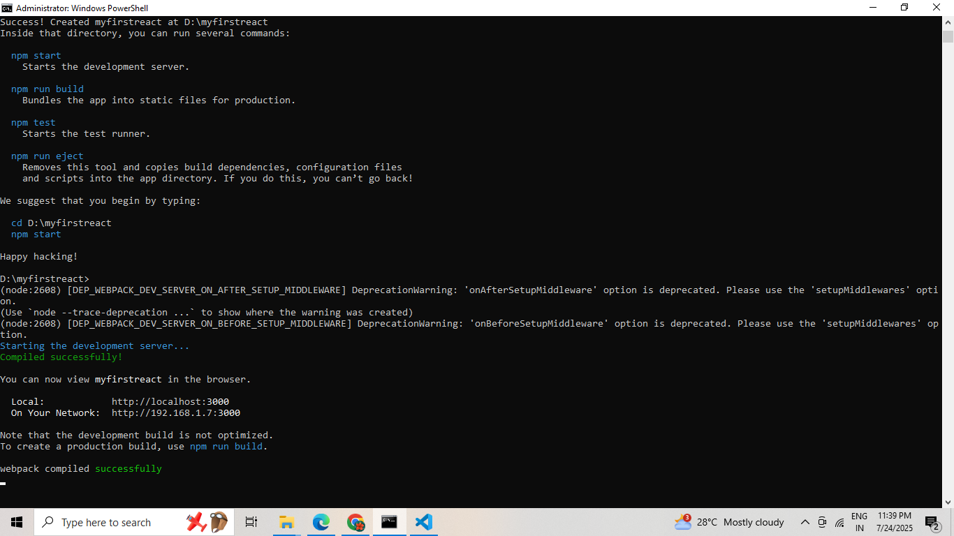

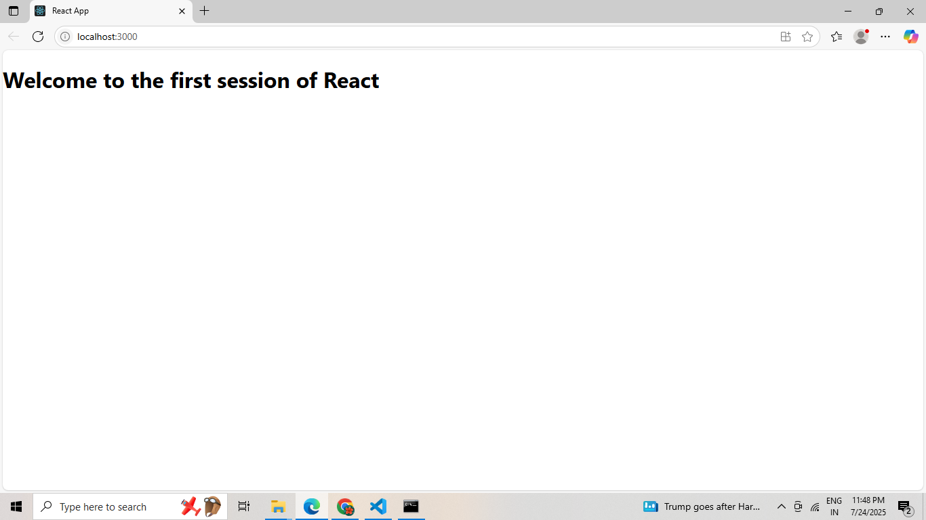

**2.ReactJs-HOL**

**MY CODE:**

**App.js**

import React from 'react';

import Home from './Components/Home';

import About from './Components/About';

import Contact from './Components/Contact';

function App() {

return (

<div className="App">

<Home />

<About />

<Contact />

</div>

);

}export default App;

**Home.js**

import React from 'react';

class Home extends React.Component {

render() {

return <h2>Welcome to the Home page of Student Management Portal</h2>;

}

}

export default Home;

**About.js**

import React from 'react';

class About extends React.Component {

render() {

return <h2>Welcome to the About page of the Student Management Portal</h2>;

}

}

export default About;

**Contact.js**

import React from 'react';

class Contact extends React.Component {

render() {

return <h2>Welcome to the Contact page of the Student Management Portal</h2>;

}

}export default Contact;

**OUTPUT:**

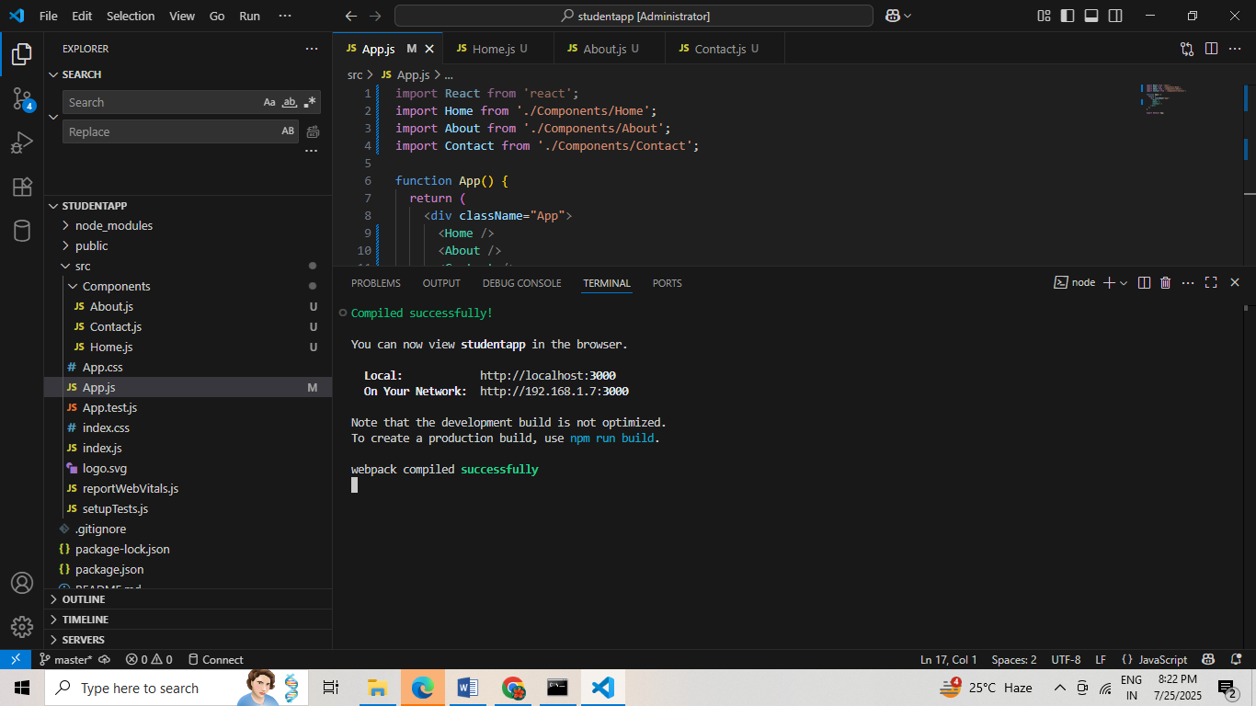

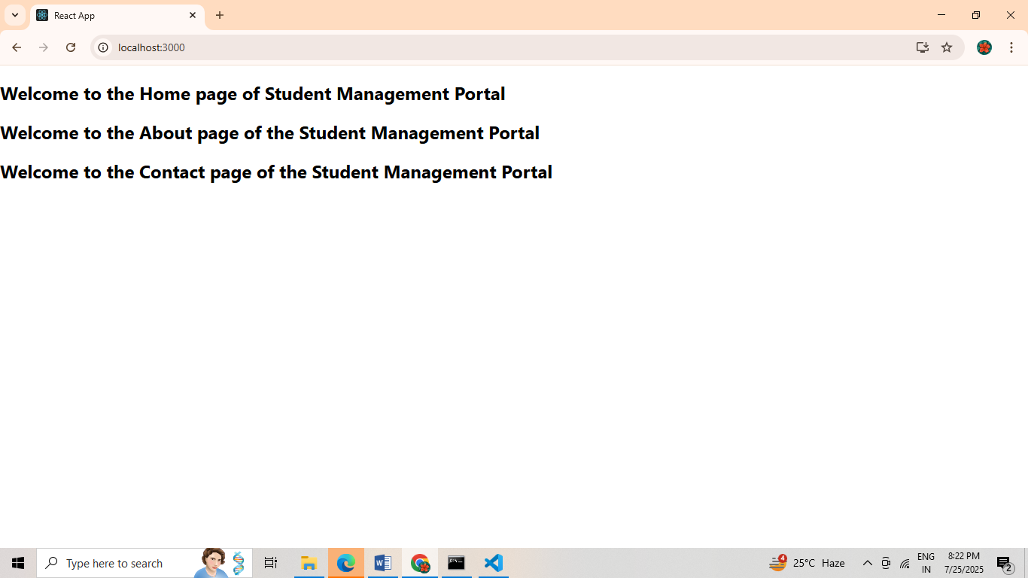

**3.ReactJs-HOL**

**MY CODE:**

**Calculatescore.js**

import React from 'react';

import '../Stylesheets/mystyle.css';

function CalculateScore(props) {

const average = props.total / 5;

return (

<div className="score-box">

<h2>Student Score Report</h2>

<p><strong>Name:</strong> {props.name}</p>

<p><strong>School:</strong> {props.school}</p>

<p><strong>Total:</strong> {props.total}</p>

<p><strong>Goal:</strong> {props.goal}</p>

<p><strong>Average Score:</strong> {average}</p>

</div>

);

}

export default CalculateScore;

**App.js**

import React from 'react';

import './App.css';

import CalculateScore from './Components/CalculateScore';

function App() {

return (

<div className="App">

<CalculateScore

name="John Doe"

school="Greenwood High School"

total={450}

goal="Achieve above 90%"

/>

</div>

);

}

export default App;

**OUTPUT:**

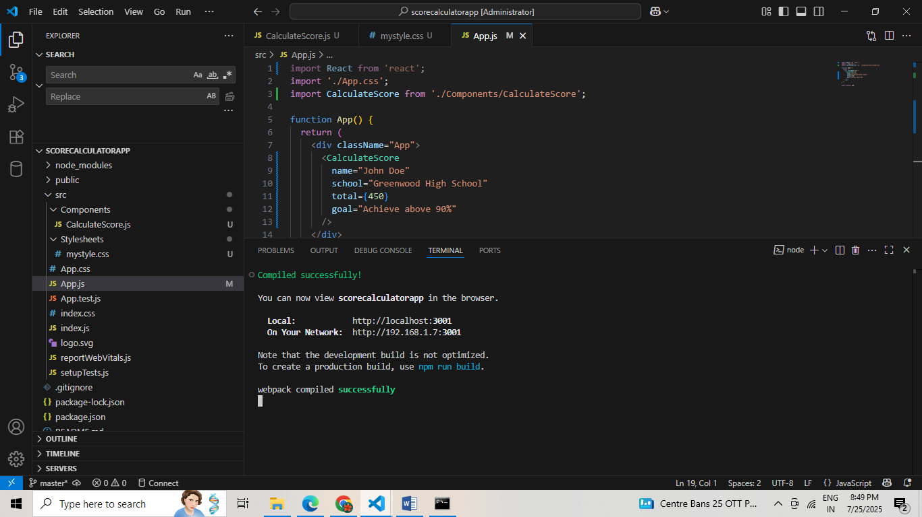

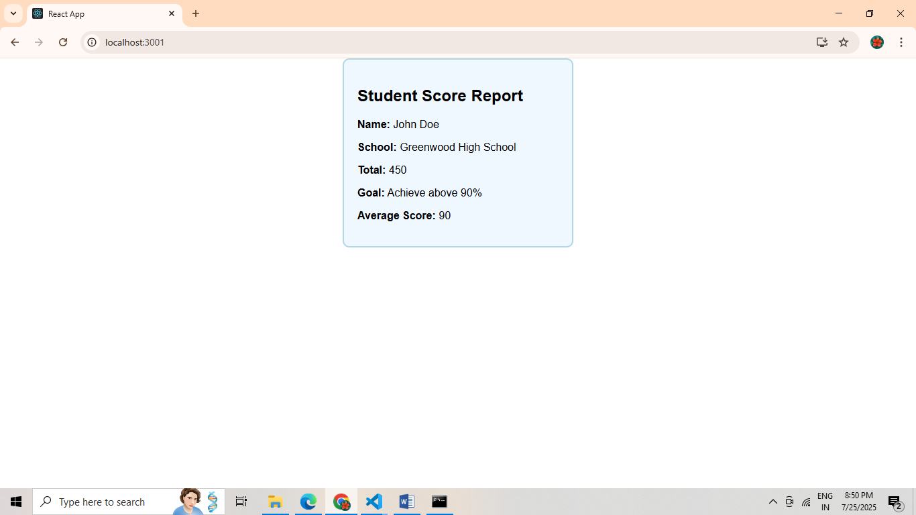

**4.ReactJs-HOL**

**MY CODE:**

**App.js**

import React from 'react';

import Posts from './Posts';

function App() {

return (

<div className="App">

<h1>Blog App</h1>

<Posts />

</div>

);

}

export default App;

**Post.js**

import React from 'react';

class Post extends React.Component {

render() {

const { title, body } = this.props;

return (

<div>

<h3>{title}</h3>

<p>{body}</p>

</div>

);

}

}

export default Post;

**Posts.js**

import React, { Component } from 'react';

import Post from './Post';

class Posts extends Component {

constructor(props) {

super(props);

this.state = {

posts: [],

hasError: false

};

}

loadPosts = () => {

fetch("https://jsonplaceholder.typicode.com/posts")

.then(response => response.json())

.then(data => this.setState({ posts: data }))

.catch(error => console.error("Error fetching posts:", error));

};

componentDidMount() {

this.loadPosts();

}

componentDidCatch(error, info) {

this.setState({ hasError: true });

alert("An error occurred: " + error.toString());

}

render() {

if (this.state.hasError) {

return <h2>Something went wrong.</h2>;

}

return (

<div>

<h2>All Posts</h2>

{this.state.posts.map(post => (

<Post key={post.id} title={post.title} body={post.body} />

))}

</div>

);

}

}

export default Posts;

**OUTPUT:**

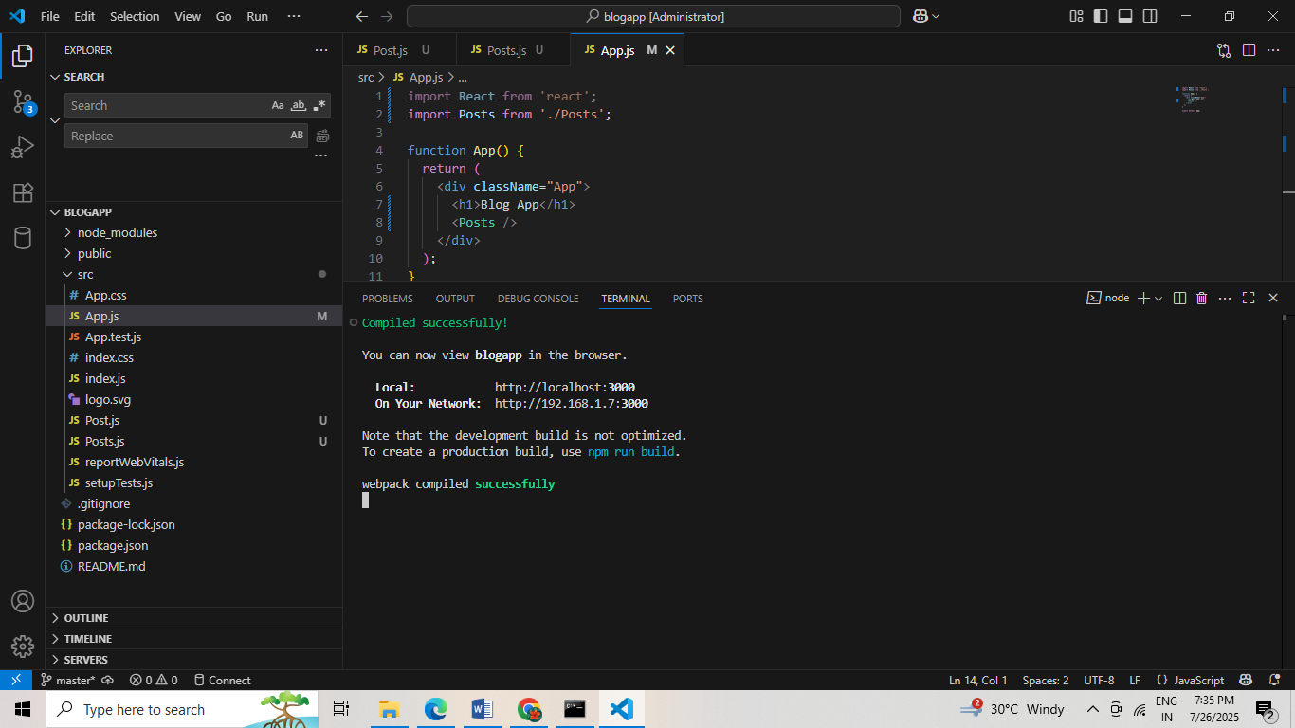

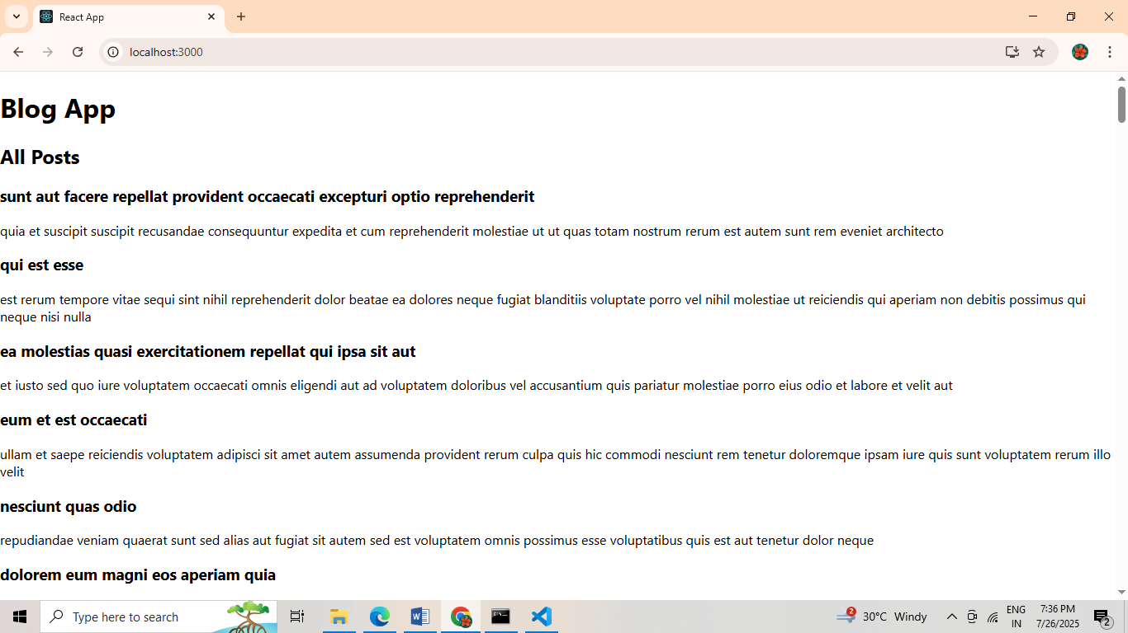

**5.ReactJs-HOL**

**MY CODE:**

**CohortDetails.js**

import React from 'react';

import styles from './CohortDetails.module.css';

const CohortDetails = ({ cohort }) => {

const titleColor = cohort.status === 'ongoing' ? 'green' : 'blue';

return (

<div className={styles.box}>

<h3 style={{ color: titleColor }}>{cohort.name}</h3>

<dl>

<dt>Status:</dt>

<dd>{cohort.status}</dd>

<dt>Start Date:</dt>

<dd>{cohort.startDate}</dd>

<dt>End Date:</dt>

<dd>{cohort.endDate}</dd>

</dl>

</div>

);

};

export default CohortDetails;

**CohortDetails.module.css**

.box {

width: 300px;

display: inline-block;

margin: 10px;

padding: 10px 20px;

border: 1px solid black;

border-radius: 10px;

}

dt {

font-weight: 500;

}

**OUTPUT:**

